Day 6 Activity1 Worksheet Your name: ________

Task A
Circle the characters with the component “斤“.

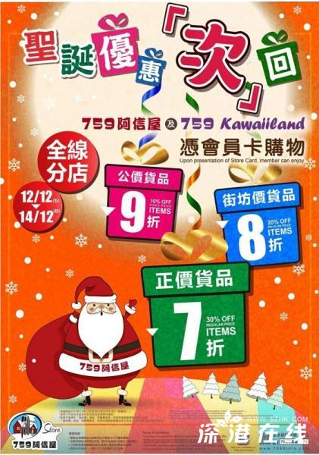

Task B: “斤” 在哪儿？
Where is “斤” located in each character?
1.斧fǔ 2.所suǒ 3.断duàn 4.新xīn 5.折zhé
6.哲zhé 7.欣xīn 8.匠 jiàng 9.芹qín

Identify the position of “斤” in each character and write the number of the character.

On the left：

On the right：

At the bottom：

At right-up corner：

Inside:右边左 边

